**What is a Seed-Phrase ?**

In the crypto world, a seed phrase serves your security. Only with a seed phase can you as an investor access your assets secured in a wallet.

A seed phrase is a random sequence of words, usually 12 or 24 words, that you should write down and keep in a safe place.

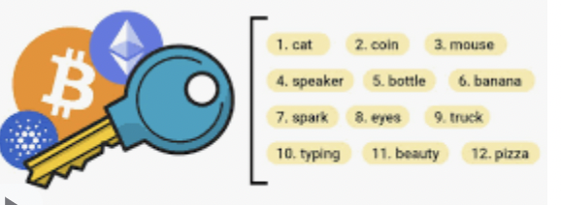

If you no longer know the seed phase, then you no longer have access to your wallet and your assets. The seed phase is therefore one of the most important topics in the crypto sector.

Please never keep it public - you should never share the seed phase with others or online.

Your wallet can only be restored with your seed phrase!